Integrated Development Environments

One of the most important tools for designing, building and testing software is the Integrated Development Environment, or IDE. The IDE is an application development platform used by modern enterprises to design, build and test enterprise software applications; but it is also the repository for storing any of the artifacts that are used to document the development process. IDEs typically cover the entire application development lifecycle. There are many IDEs available in the market place. Some are proprietary where licenses can be purchased from the vendor, some are open source where licenses can be purchased from a distributor, some are freeware and can be made available for at no charge and some are hybrids of proprietary and open source and are made available with a variety of purchasing/leasing options.

One of the major challenges that information managers face is the selection of the IDE. The IDE needs to be appropriate for the nature of the work their IT professionals need to perform. Before embarking on the selection path armed only with hype, half-truths and sales brochures consider the following areas that may help you with your decision making.

Operational platform -- What is the target operating system and hardware where the IDE is intended to operate? That is … will it be installed to run under Linux (which distribution), Unix (which version), Windows (which version), z/OS or other operating system? Can the IDE connect to one than one environment?
- Target platform -- What are the target operating systems and hardware where the objects and artifacts created using the IDE are intended to be executed? That is, will the newly-created objects run under Linux (which distribution), Unix (which version), Windows (which version), z/OS or other operating system? Is the IDE capable of producing multi-platform objects? This is very different from number 1 above.
- Capabilities -- Does the IDE support the full systems development lifecycle as identified by Winston Royce’s, “Managing the Development of Large Software Systems?” That is, are there tools to support all five of the lifecycle phases? Does the IDE support the programming languages that your enterprise uses or is the IDE designed around one specific programming or scripting language? Does the IDE have the basic complement of implementation phase support tools: editors, compilers or interpreters, code (class) libraries, debuggers, templates, multiple user interfaces? Can your IT staff access multiple computing platforms at the same time or are you restricted to a single platform?

In this lab you will explore RDz, an enterprise IDE called Rational Developer for System Z. RDz is based on the open-source IDE, Eclipse, and while using it you will learn the following.
Learning Outcomes
The student will be able to:
- Explain the management issues when selecting an IDE
- Explain the basic components of an IDE
- Describe the general and specific uses of an IDE
- Describe the major features of RDz
- Use RDz to create computer “libraries” or folders where files can be organized

Lab Exercise
In this lab you will explore the capabilities of RDz. It is also the lab that sets up your development environment so that you have places to store you program source code and executable objects. As you are working through the steps in this lab be mindful of the questions posed at the end of this lab exercise.

- To launch RDz as described in the “Guidelines for connecting to System z.”

- Right click on your newly created GET239 Connection for a drop down menu and select Connect. This will give you a dialog box to enter your SUS User ID and new Password.

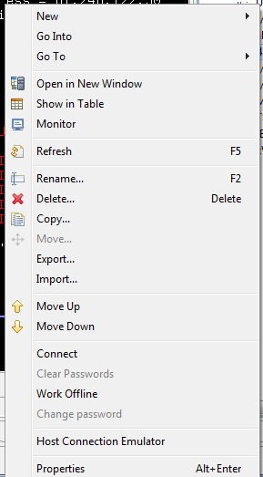
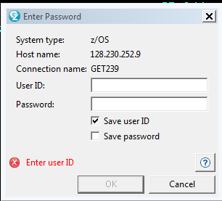

- In this lab exercise we are going to explore RDz and its relationship with the Enterprise Server, the System z10. We are using this lab to create some of the files you’ll need when you start building programs.

In the typical application development environment computer software or programs are stored in libraries. We are going to build libraries by creating the directories (and associated files) that allow us to categorize various program components: Source code, Load Modules and the Job Control Language need to prepare then execute your programs.

- After you have connected to the Enterprise Server you may see some operating system-created files that look similar to these; but don’t concerned if there are no files already present you will be creating some shortly.

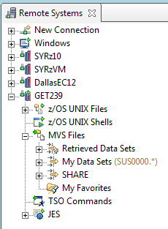
It is in MVS → My Data Sets where we plan to put our libraries.

MVS is an acronym that means Multiple Virtual Systems and is the kernel of the z/OS operating system. We’ll cover this more in detail later in the semester

- We are going to run a utility program supplied by the operating system, IEFBR14, to create and catalog the files we plan to use for our libraries. You will find this program already set up and ready to run in sharable library located in the library named SHARE.GET239.JCL. The job you will run is called CREATEDS; which stands for create data sets. To find the SHARE.GET239.JCL library and the CREATEDS job you’ll need to create an RDz Filter.

- To create a filter, right click on MVS Files. You should see the following drop down menus. Select New → Filter

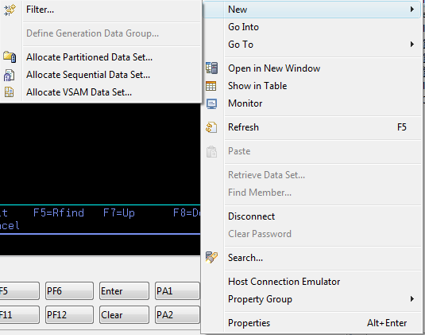

Type in the name or wild card string of the files you want selected by your filter. Here I used a wild card string “SHARE.*” for all files that start with “SHARE” then click next:

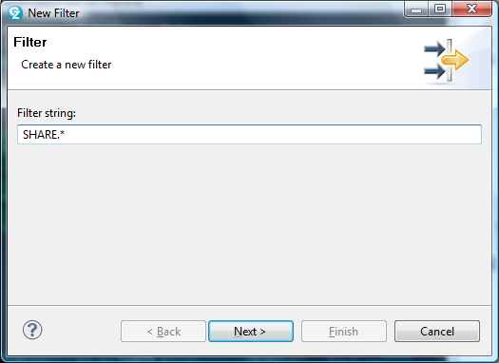

Give your filter a name. Here I used the name “SHARE” then click Finish

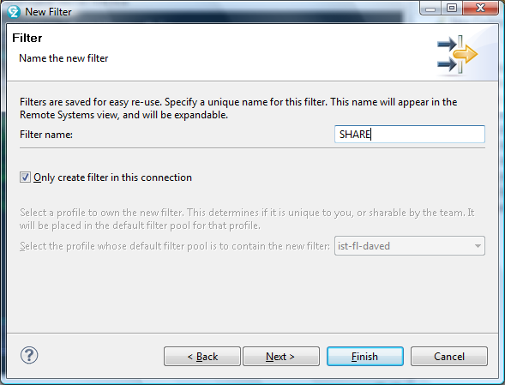

- You will see the Filter in your Remote Systems Explorer → MVS Files → SHARE. Open the SHARE folder and you will see a number of data sets (files.) Find the Library name SHARE.GET239.JCL. Find the file CREATEDS. Double click on it and it will open up in an editor. From here it can be modified or submitted to the operating system.

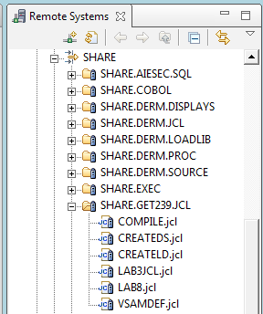

CREATEDS is a procedure that I built to create libraries for you to store your programs and job control language

In CREATEDS is the JCL (i.e. script) you need to create the libraries. All we need to do is submit this script to the operating system.

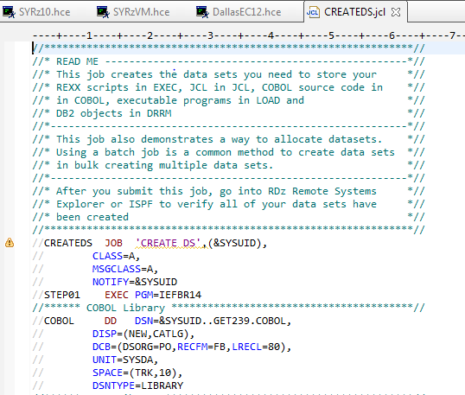
Here you can see in the script that creates the COBOL source code library
- Right click on the JCL and you will get a drop down menu where you can Submit the JCL as a workload to the operating system:

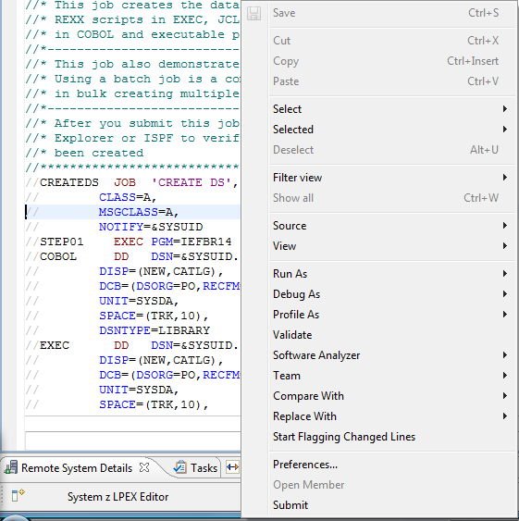

- After you submit the workload it should run pretty quickly. You’ll notice that after the job ran your libraries were built. You will be using these libraries in future lab exercises as you build COBOL programs.

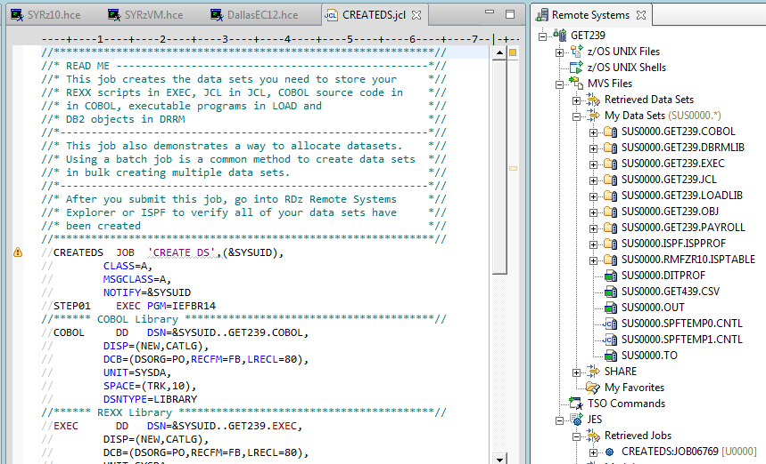

Here you can see the output i.e. the results of your Job’s execution in the operating system’s Job Entry Subsystem

Lab Worksheet

Your Assignment: Explore RDz using its tutorials; then proceed to the next few pages to answer the questions about your experience with RDz. Use the digital copy on Blackboard to type (not hand write) your lab answers. Use this as a worksheet to just collect your data. (20 points)

- Print the screen that reflects your MVS Files (see page 8 above) showing the five libraries you have created then attach it to typed answers. (5)
- RDz is an integrated development environment. Based on its capabilities and functionality, explain why IDEs are an important part of an enterprise’s technology. (5)
_____________________________________________________________
_____________________________________________________________
_____________________________________________________________
_____________________________________________________________
_____________________________________________________________
_____________________________________________________________
_____________________________________________________________
_____________________________________________________________
- List four programming languages that RDz supports: (4)
a. _______________________________________________
b. _______________________________________________
c. _______________________________________________
d. _______________________________________________

- Describe the purpose of a perspective, view and editor? (3)
a. Perspective: _________________________________________________
_____________________________________________________________
_____________________________________________________________
b. View: _____________________________________________________
_____________________________________________________________
_____________________________________________________________
c. Editor: _____________________________________________________
_____________________________________________________________
_____________________________________________________________
- Describe three management considerations for selecting an enterprise IDE? (3)
1. ______________________________________________________________
_____________________________________________________________
_____________________________________________________________
_____________________________________________________________
_____________________________________________________________
2. ______________________________________________________________
_____________________________________________________________
_____________________________________________________________
_____________________________________________________________
_____________________________________________________________
3. ______________________________________________________________
_____________________________________________________________
_____________________________________________________________
_____________________________________________________________
_____________________________________________________________

Royce, Winston, “Managing the Development of Large Software Systems”, Communications of the ACM, June 1970

